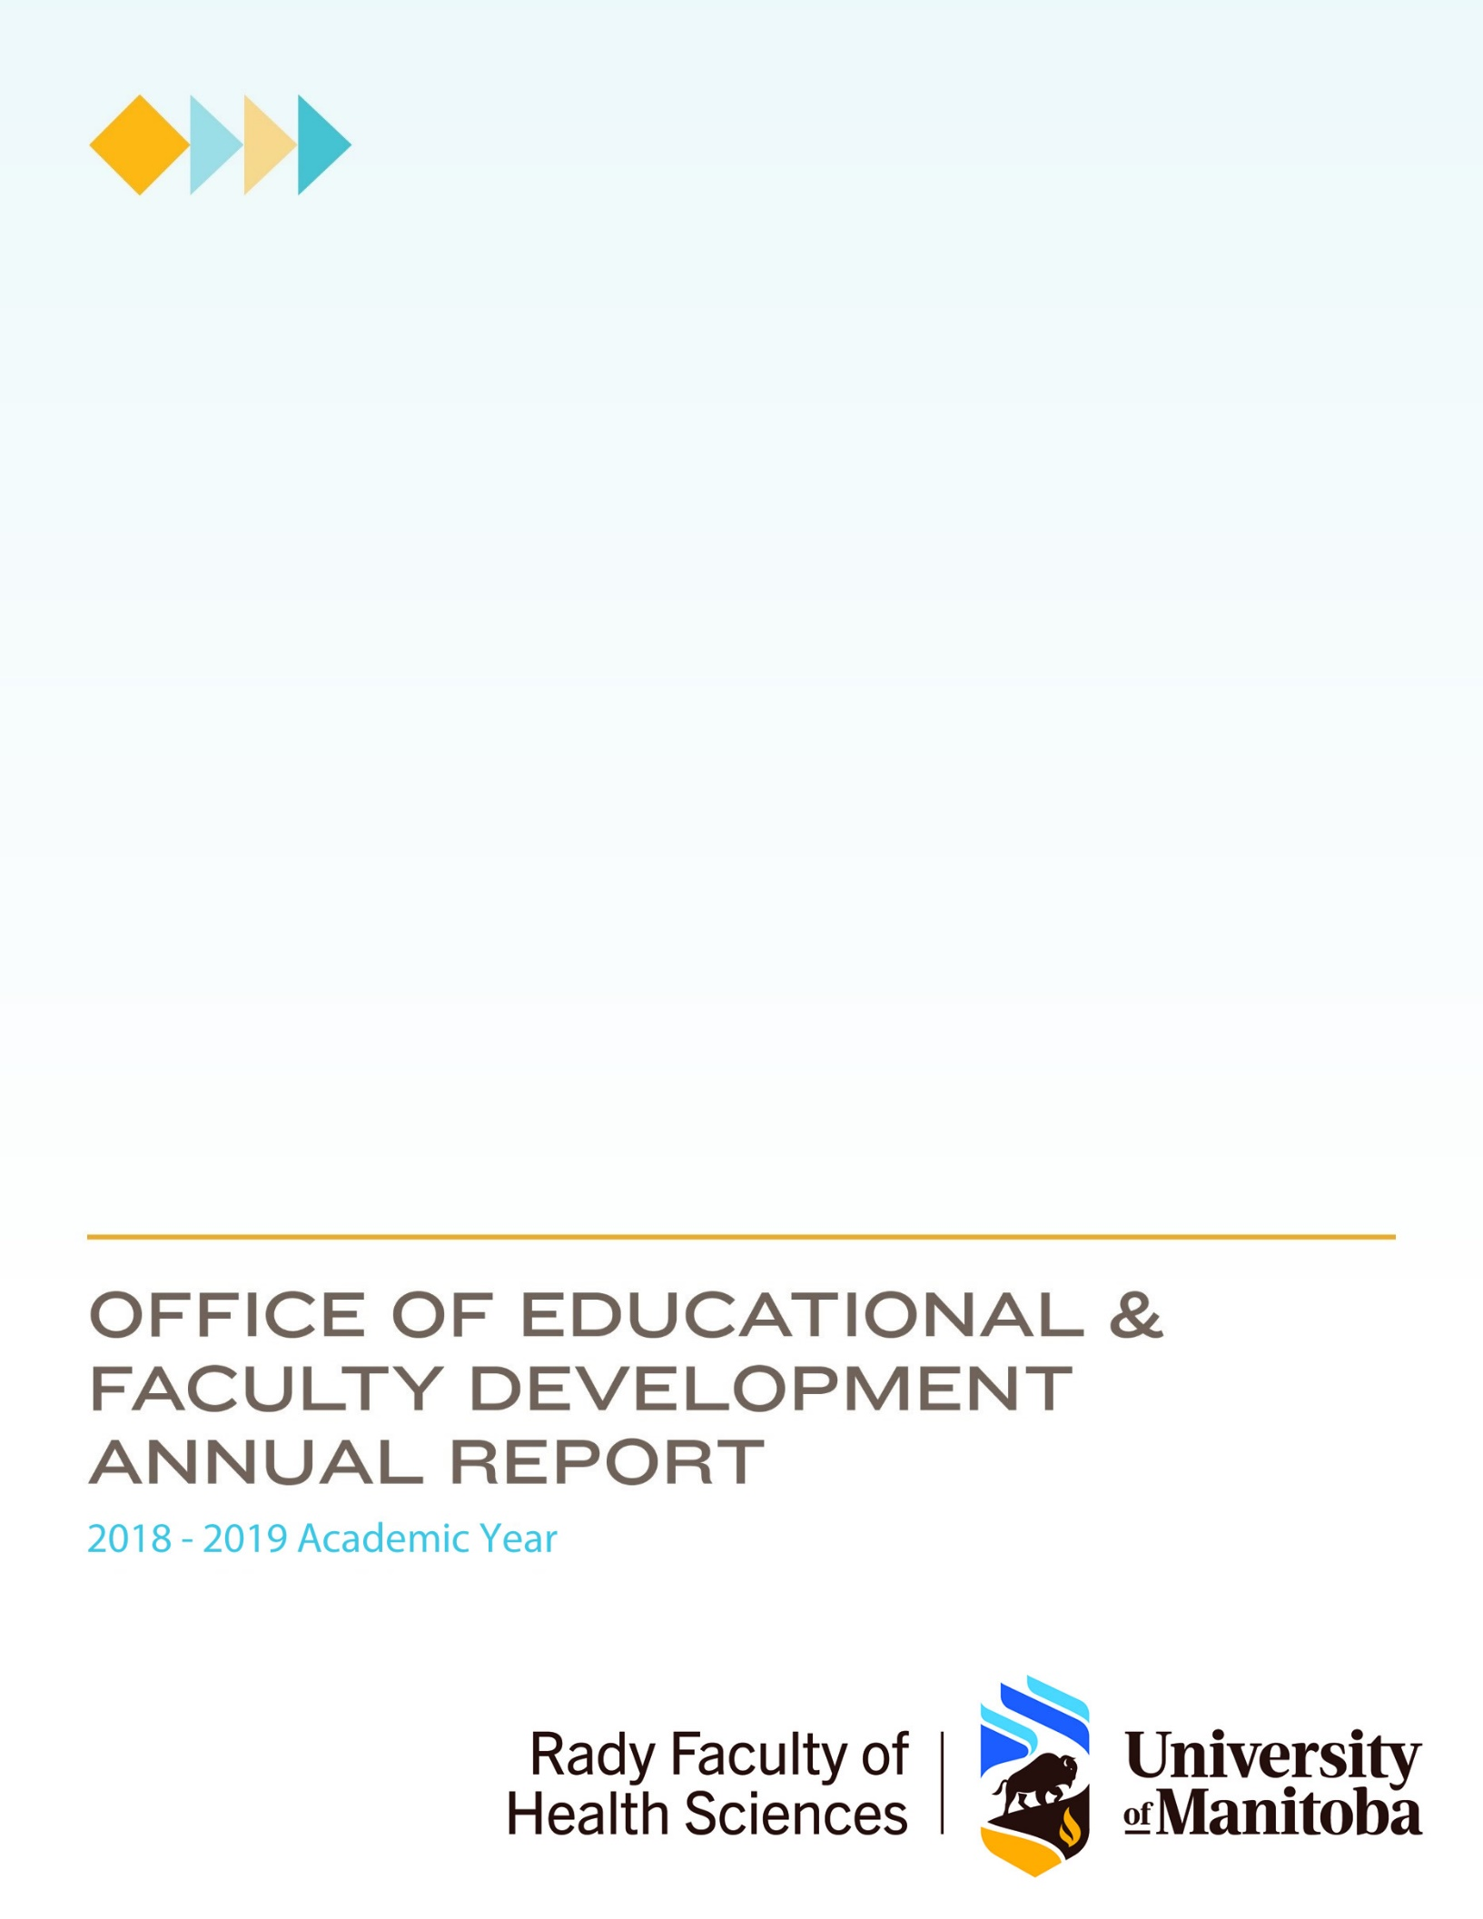

Table of Contents
Executive Summary 4
Our Third Year 5
Growing. 5
Strategic Planning. 5
Our Team. 5
Our Service Model 7
Our Activities 7
Faculty Development 8
Communications strategy: 10
Curriculum Development 10
Program Evaluation and Educational Research 12
Scholarly Work 14
Organizational Development 15
Service 16
National/International 16
University of Manitoba 16
College Specific Activities 16
College of Nursing 16
College of Pharmacy 16
College of Rehabilitation Sciences (CoRS) 17
Dr. Gerald Niznick College of Dentistry 17
Max Rady College of Medicine (MRCoM) 17
Looking Ahead 20
Appendix 1 Strategic Priorities of OEFD – 2016 - 2021 21
One-Year Goals: 21
Five-Year Goals 21
Appendix 2 Members and Roles in OEFD 22
Appendix 3 Faculty Development Activities 2018/2019 Academic Year 23

List of Tables and Figures
Table 1. Our Current Team 6
Table 2 Faculty Development Activities for the 2018/2019 year 9
Table 3 Curriculum Development Support for the 2018/2019 year 10
Table 4 Research and Evaluation Activities for the 2018/2019 year 13
Figure 1 Our Service Model and Philosophy 7
Figure 2 Our Functional Chart 8

Executive Summary
The 2018/2019 year was one of continued growth for the Office of Educational and Faculty Development (OEFD). We again saw an increase in the number of faculty development workshops we offered, and almost 500 more participants. We also provided support for the Rady Faculty of Health Sciences (RFHS), in the areas of curriculum development and innovation, educational research and program evaluation, and targeted faculty development.
OEFD Mission Statement
The Office of Educational and Faculty Development in the Rady Faculty of Health Sciences is a resource for promoting excellence in teaching and scholarship across the continua of health professions education. Through evidence informed practice, Office members engage in and support curriculum development and innovation; educational research and program evaluation; and faculty development activities that assist faculty members in their roles as educators, researchers and administrators.
We delivered over 95 faculty development workshops in the 2018 -2019 academic year, reaching 1846 participants with over 211 hours of faculty development programming. We continued to deliver a selection of our faculty development offerings via distance delivery and added podcasts to our suite of faculty development tools available to community-based, rural, and remote faculty members. We once again delivered our course focused on preparing faculty to teach online.
In the area of curriculum development and innovation, we have been working with a number of programs to support interactive online and distributed learning, using innovative tools such as PowToon and Articulate Storyline. We continue to contribute to the interdisciplinary health program, and at the College level, to the ongoing development of the PharmD program, a proposed speech language/audiology program, and the Postgraduate Medical Education (PGME) Core Curriculum. We are continuing to provide leadership and pedagogical support for the implementation of competency-based medical education in PGME. Finally, we are supporting the introduction of Entrada across the Rady Faculty and leveraging its features for curriculum mapping, faculty development, and community building.
Supporting rigorous and relevant program evaluation processes has been a growing area of need across the RFHS. We have supported the development of evaluation frameworks in a number of educational programs, including physiotherapy, occupational therapy, physician assistant studies, pharmacy, nursing, and undergraduate and postgraduate medicine. This includes designing evaluation frameworks and data collection tools, and supporting data analysis.
Educational research continues to focus on problems of practice encountered by our faculty members and learners. Our growing list of research projects aims to tackle such problems as improving narrative feedback for learners, evaluating programs, and understanding the development of clinical reasoning and patient documentation skills. Finally, at the College level in organizational development, we facilitated the Occupational Therapy, Physical Therapy, Respiratory Therapy, and Interdisciplinary Health Program strategic planning retreats.
Ultimately, as much of our work is invisible to the casual observer, this annual report is meant to highlight some of the important work of the members of OEFD.

Our Third Year
Growing. This was our third year of operation, and it continued to be one of significant growth. We offered more faculty development workshops, which reached a larger audience, and developed more webinars and podcasts for our distributed faculty. Our support for program evaluation expanded to the Colleges of Rehabilitation Sciences, Nursing, and Pharmacy, providing guidance on evaluation design, collection methods, and providing support for analysis. We supported the Undergraduate Medical Education (UGME) accreditation, and the PGME implementation of CBME/CBD. We continue to see a growing demand for online and blended learning, and a desire to explore more innovative approaches to learning that foster student engagement.
Our Five-Year Vision
OEFD is seen as a highly valued component of the Rady Faculty of Health Sciences. Our work makes a difference and contributes to the mission of the faculty, its colleges, and the university as a whole.
Strategic Planning. We continue to work on our strategic plan (see Appendix 1 for strategic priorities of OEFD). Communication with stakeholders, particularly as it relates to faculty development events, remains a challenge. We continue to explore ways to better engage with faculty at community-based and distributed sites, and this remains a key strategic priority for 2019/2020.
Our Team. Within OEFD, each member has defined roles and responsibilities (Table 1); however, some roles are shared by all members, such as facilitating OEFD journal club and communicating with stakeholders. These duties are shared to enact scholarly practice, lifelong learning, and quality improvement. They also promote a culture where professional activities are informed by research, with feedback from peers and time for reflection are integral parts of our professional practice. In different ways, each activity contributed to professional development in a local and relatively inexpensive way. As such, we enriched our community of practice.

We added a position in the office to support program evaluation and student assessment across all five Colleges, but with a specific focus on undergraduate medicine. This position was filled by Ryan Day, who also brought with him skills in the area of online learning and knowledge mobilization. Only one individual left the OEFD in 2018/2019, our Educational Specialist, Stephanie Giberson-Kirby, who relocated to another province. Kathleen Legris was hired to fill this vacancy, bringing expertise in program planning, online learning, and curriculum development. Holly Madden replaced Marcia Langhan as Business Manager. Laurie Driedger came aboard as Faculty Development Coordinator and administrative support. Our 2018/2019 team is outlined in Table 1.
Table 1. Our Team
Name | Position | Responsibilities
Joanne Hamilton, BHEc, RD, MEd, EdD(c) | Director of the Office of Educational and Faculty Development | Rady Faculty of Health Sciences liaison  Max Rady College of Medicine liaison  Special Projects lead  Educational Research support
Christen Rachul, BA, MA, PhD | Director of Research and Evaluation | Educational Research Lead  Evaluation support
Marcia Langhan, BA, LLB | Business Manager | Finance  Human resources  Newsletter managing editor  Policy and planning
Holly Madden, CPA, CGA | Business Manager | Finance  Human Resources  Policy and Planning
Ryan Day, BEd, MEd (c) | Educational Specialist | Assessment and Evaluation  Knowledge mobilization
Karen DePape | Faculty Development Coordinator | Coordination of faculty development events  Support for Directors
Laurie Driedger | Faculty Development Coordinator | Coordination of faculty development events  Payroll, purchasing, Database management
Anita Ens, BA, BTh, MEd, PhD | Educational Specialist, Director, Faculty Development – Department of Family Medicine | Max Rady College of Medicine liaison  Faculty development lead – family medicine
Stephanie Giberson-Kirby, BA (Hons), BEd, MCE | Educational Specialist | Pharmacy liaison (to Jan 2019)  Career development lead
Kathleen Legris, BFA, BEd, MEd | Educational Specialist | Faculty Development lead  Knowledge mobilization
Helen Mawdsley, BSc, MAL(H), EdD | Educational Specialist | Assessment and Evaluation lead
Ingrid Toews, BA, BEd, MSc, PhD | Post-licensure Communication Skills Facilitator | Communication skills lead  IPE liaison  Remediation specialist
Tanya Walsh, BA, BSc, MET | Educational Specialist | CBD educational development support  Educational technology support  Pharmacy liaison (from Jan 2019)
Steve Yurkiw, BEd, MEd | Educational Specialist | CoRS liaison  Online learning lead

Our Service Model
Based on our mission and vision we have developed the service model as depicted in Figures 1 and 2.
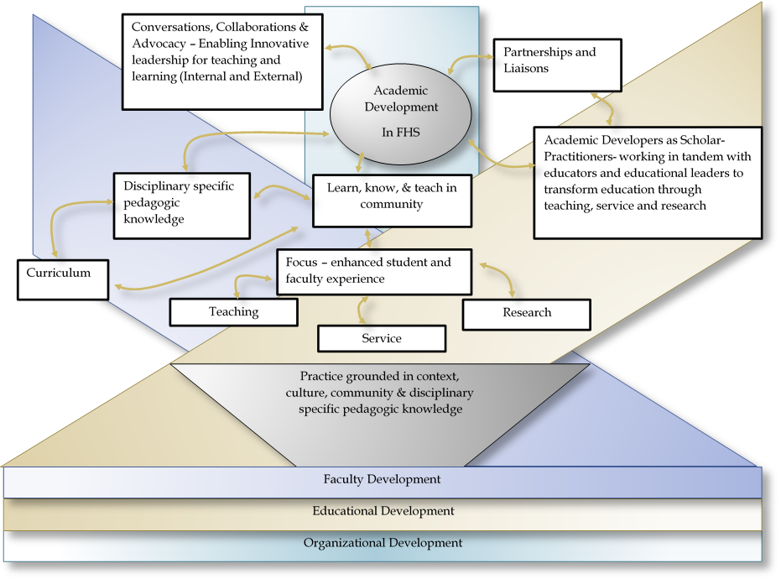
  - Figure 1 Our Service Model and Philosophy

Our Activities
The Office of Educational and Faculty Development offers services at the Rady Faculty level, to its member Colleges, as well as to individual programs and departments. These activities include faculty development, educational development, educational research and evaluation, and some aspects of organizational development.
As part of informed service and support to the Rady Faculty, OEFD members surveyed faculty (online survey) and interviewed College and Rady Faculty educational leaders one-to-one regarding their perspectives, needs, and priorities in educational and faculty development. A systematic analysis of this data, along with emerging research, and changes from regulatory and accrediting bodies informs our faculty development planning process.

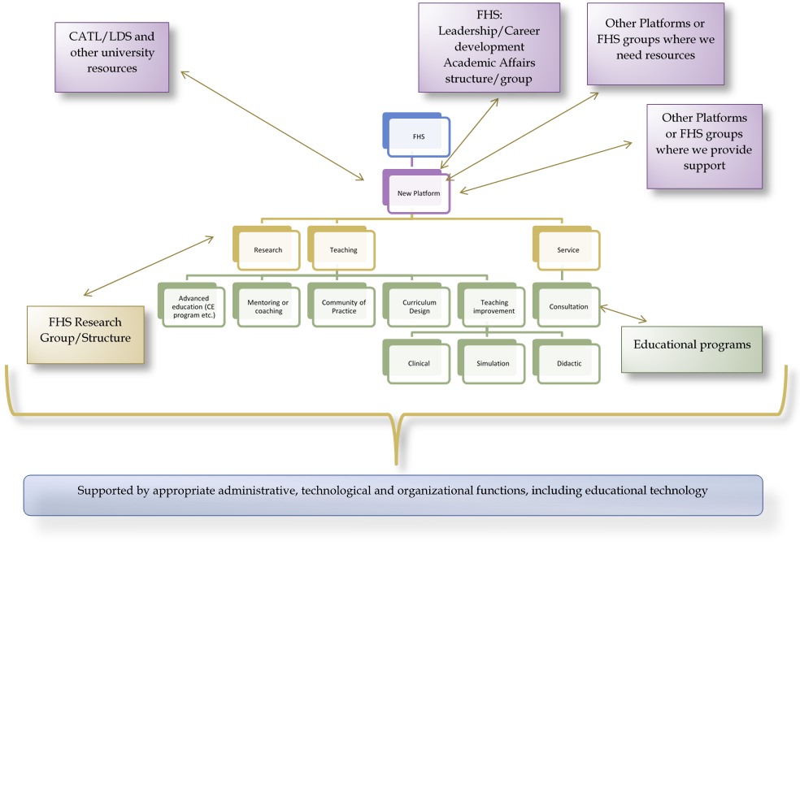
Faculty Development
Figure 2 Our Functional Chart
In the 2018/2019 academic year, we provided faculty development in the areas of teaching, research, career development, and the health humanities. Faculty members from all five Colleges, as well as the RFHS, attend our events (figure 3). A summary of offerings is in Table 2. A full listing of sessions offered can be found in Appendix 3.
Innovations this year include the development of podcasts as a resource for faculty teaching in small groups or tutorials, a new workshop titled ‘Exposing the Hidden Curriculum’, and a visiting speaker series focused on the health humanities. We also hosted two visiting speakers focused on qualitative research methods, to continue to build a vibrant community of educational researchers. We continue to offer a mix of offerings, both face-to-face and via webinar. Evaluation of the events by participants is uniformly positive, with participants often offering suggestions for future events. Importantly, much non-traditional faculty development occurs through OEFD member participation on curriculum related committees. In these roles, OEFD members can help educational leaders through regular conversations about best practices in teaching, learning, and curriculum design that foster educational innovation and excellence.
Table 2 Faculty Development Activities for the 2018/2019 year
Faculty Development Topic Area | Number Sessions | Number of Attendees
Teaching and learning | 43 | 617
Curricular design | 6 | 80
Program evaluation and educational research | 10 | 146
Resident faculty development (MRCoM)* | 10 | 719
Graduate student faculty development | 5 | 48
Career development | 10 | 154
Journal club/Hamlet | 13 | 82
Total (includes concurrent webinars) | 96 | 1824
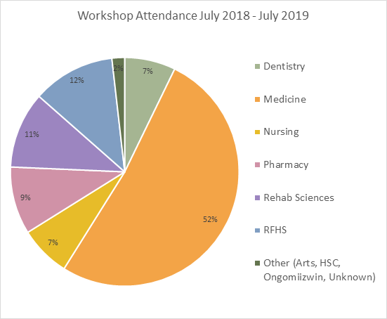
*requirement of UGME accreditation
Figure 3 Workshop Attendance

Moving forward, our faculty development plan will continue to evolve to meet the needs of both faculty members and educational programs in the RFHS. We are expanding our offerings in the health humanities. We will offer more opportunities for faculty to explore topics such as educational leadership, authentic assessment, and educational research. Arising out of the UGME accreditation, we will provide more support for faculty teaching in small groups, engage distributed faculty members in faculty development, as well as collect more data about who is attending our events.

Communications strategy:
Communications play a key part of the OEFD faculty development strategy. We continue to use our website and social media to communicate about our programs, as well as provide resources to faculty. We are also in the process of developing infographics focusing on teaching in the clinical setting that sites can post to provide guidance around topics such as giving feedback, coaching, and clinical teaching strategies. However, due to the increased demand for faculty and educational development from our stakeholders, we have had to cease publication of our newsletter. The last issue was published in winter 2019, focusing on excellence in teaching across the RFHS. Our 2018/2019 newsletters were:
- 2019 Issue 1 Teaching Excellence
- 2018 Issue 3 Teaching and Learning in the Workplace

Curriculum Development
Curriculum development and innovation is a core function of OEFD, and continued to be an area of growth for OEFD in 2018/2019. Work in this area has ranged from simple consultations regarding mapping of curriculum, assistance with developing online components for courses, to leading the revision of an entire curriculum. Table 3 outlines some of the activities in this area. These activities may be led by OEFD members, but are typically done in partnership with faculty members and subject matter experts.
Table 3 Curriculum Development Support for the 2018/2019 year
Activity/Program | Description
Peer Review of Teaching Program | Development of a peer review of teaching program. Expected launch 2019/2020
Online course Introduction to Educational Research | Development of an asynchronous course on educational research. Course will be launched in 2019/2020.
Development of Core Curriculum for PGME | Developed and maintain courses in the PGME core curriculum: diversity, prescription writing, resident and the learning environment, professional boundaries, teaching development program, and conflict management
Competency Based Medical Education | Co – lead and provide pedagogical advice and guidance for the implementation of CBD in PGME, including advising on assessments, mapping, communication, faculty development, and research/evaluation
Mapping of the UGME curriculum | Map sessions and courses to the UGME global objectives, mapping of curricular themes.
PGME – CBD resource development | Development of teaching and learning resources for the implementation of CBD in postgraduate medicine
Revision of DFM preceptor toolkit | Resource for community-based preceptors
Pharmacy professionalism course | Developed rubrics, supported debating activity, coached debaters
Development of resource toolkit for struggling clinical learners | Curation and creation of resources for clinical faculty working with learners who are struggling. Designed to support learning and remediation processes
Developed a rubric for MPAS | For use in a case-based learning exercise for MPAS students
Updated standardized patient online orientation program | Delivered successfully to three groups
Development of TDP0 – an introduction to clinical teaching for residents | To address accreditation issues related to residents preparation for teaching medical students, developing an online orientation module to review learning objectives, and clerkship rotations
Developed a series of podcasts on small group teaching | Created for faculty development resource for UGME Tutorial Leaders
Recorded seven webinars | Recording of OEFD faculty development Noon Hour sessions
Supporting webinar meetings across RFHS | TISLEP and Sanokondu National Committee Meeting (27 sessions); College of Pharmacy (2 student placement debrief sessions and 2 accreditation focus groups); Family Medicine (3 webinars); Dept. of Physiotherapy (4 webinars); College of Nursing (4 webinars)
Designed chronic pain units of study | For online delivery, development of modules on chronic pain, with Department of Clinical Psychology/Master of Physiotherapy program
Created three online resources | For Medical Biochemistry (MED-7120) – one assigned study and two voice over PowerPoints
Developing online resource stewardship module | Presently working on the development of Online Resource Stewardship course for PGME Core Curriculum
Lecturing podcast series | Developing a Podcasting Series on “The Science and the Art of the Lecture”
RFHS/CoRS peer to peer clinical skills/physical exam | Environmental scan within the Rady Colleges and externally on policies and procedures for learner participation in peer physical exams and clinical skills. Review and recommendations
MPAS evaluation report: graduate survey | Report summarizing Physician Assistant 8 month post-graduation survey
Developing professionalism pledge module | Developing, in partnership with Office of Professionalism, a professionalism pledge module for medicine. Lead: Ryan Day
Development of a SLP and Audiology curriculum and program proposal - CoRS | Working with CoRS, development of an innovative SLP/Audiology curriculum, and support for the development of a program proposal
Patient safety curriculum project | Development of a common curriculum framework for use across the Rady faculty - ongoing
Curriculum retreat/review IHP program | Supported a curriculum review retreat for the IHP program in response to external review
IHP program evaluation | Development and support for the IHP graduate survey
MRCoM student mistreatment survey | Development of and support for the analysis of the mistreatment survey
MPT accreditation | Assistance with compiling clinical education data for accreditation
MMSA, ISA survey support | Consultation with MMSA on Likert scale and question items, support for statistical analysis for annual MMSA survey on the UGME program
Professionalism modules for PGME Core Curriculum | Along with Professionalism Curriculum Committee members, created a professionalism foundations module and facilitator guide and piloted with several programs, also assisted with modules on medical error, disruptive behavior, and civility

Program Evaluation and Educational Research
Program evaluation and educational research are core activities of OEFD. Under our Director of Research and Evaluation, Christen Rachul, and our Evaluation Lead, Helen Mawdsley, evaluation and research activities over the last year have expanded significantly. Highlights include two successful research grant applications, three publications, and participation in a national research project led by the University of Toronto. We have also begun to explore a research partnership with Red River College, to explore how to better support clinical teachers. We continue to provide leadership in the area of program evaluation to help programs answer questions they have about the effectiveness of their educational programs.
OEFD has also provided supervision for a number of students, both in terms of program-based electives, as well as research projects, including for the MPAS and the BSc(Med) programs. Internally, OEFD is working to comprehensively evaluate the impact of its faculty development program using a realist approach (e.g. what works for whom and in what context), to ensure that the faculty development that we offer makes a meaningful difference for teachers and learners in the health professions. Table 4 outlines the research and evaluation projects in which OEFD is involved.

Table 4 Research and Evaluation Activities for the 2018/2019 year
Project | Description
Research Projects
Evaluation of Undergraduate Medical Education Renewed Curriculum | Exploring the impact of the renewed UGME curriculum as part of 8-year evaluation study. Principal Investigator: Joanne Hamilton. Co-Investigators: Christen Rachul, Keevin Bernstein, Ira Ripstein, Helen Mawdsley, Benjamin Collins.
Analysis of Assigned Studies in UGME | Researching the factors that contribute to an effective assigned study in order to develop guidelines for the development of more successful assigned studies in UGME. Principal Investigator: Christen Rachul. Co-Investigator: Benjamin Collins.
From Novice to Expert: Exploring the Relationship between Clinical Reasoning and Documentation Skills in Medical Students, Residents, and Family Physicians. | Conducting study that explores the relationship between the development of clinical reasoning and patient documentation skills as medical learners and physicians gain experience. Principal Investigators: Christen Rachul, Teresa Cavett. Co-Investigator: Luke Sadler (BscMed Student).
Improving Narrative Feedback for Resident-led Academic Rounds: The Effects of Evaluation Form Design Changes | Collaborating on a resident-led project in Psychiatry investigating the effects of evaluation form design on quality of narrative feedback. Principal Investigator: Sara Courtis. Co-Investigators: Wil Fleisher, Sarah Fotti, Christen Rachul.
The BWF Physician-Scientist Training Program at the University of Manitoba Max Rady College of Medicine | Collaborating on proposal for the development of a physician-scientist training program in medicine. Principal Investigator: Shayne Taback. Co-Investigators: Hani El-Gabalaway, Lisa Lix, Christen Rachul. Contributor: Joanne Hamilton.
Social Justice and Health Equity in the Teaching & Learning Environment: Perspectives of Academic Leaders in Health Profession Programs | Collaborating on a project investigating RFHS academic leaders’ visions for a teaching and learning environment that embodies social justice and health equity. Principal Investigator: Benita Cohen. Co-Investigators: Debra Beach-Ducharme, Moni Fricke, Alan Katz, Laura MacDonald, Donna Martin, Christen Rachul, Gayle Restall, Dana Turcotte.
Developing a Culture of Research in the College of Rehabilitation Sciences | Collaborating on project exploring the development of a culture of research in the College of Rehabilitation Sciences. Principal Investigator: Jacquie Ripat. Co-Investigators: Christen Rachul, Joanne Hamilton, Reg Urbanowski.
The State of the Union: Mapping Evolving Professional Stereotypes and Clinical Reasoning of Pharmacy | Collaborating on U of T project that is exploring how pharmacy students are socialized into their professional roles. Principal Investigator: Elise Paradis (U of T). Co-Investigators: Kulamakan Kulasegaram (U of T), Christen Rachul.
Evaluation of Competence By Design at the University of Manitoba | A 5-year realist evaluation study exploring what is working well for residency programs during the implementation of Competence By Design at the U of M. Principal Investigator: Christen Rachul. Co-Investigators: Joanne Hamilton, Helen Mawdsley, Ingrid Toews, Ming-Ka Chan, Ganesh Srinivasan.
Exploring Educationalist Leadership in Medical Schools | Qualitative study exploring the enactment of leadership during curriculum change. Principal Investigator: Joanne Hamilton. Supervisor: Elisabeth Bennett (Northeastern University).
Representation of Family Medicine in Preclerkship Clinical Cases: Missed Opportunities? | Exploring the way family medicine is represented in cases used in the UGME curriculum. Principle Investigator: Amanda Condon, Co-investigators: Anita Ens, Francis Diaz, Sasha Thiem (BSc Med Student)
Evaluation Projects
MPAS Program Evaluation | Analysis of graduates and employers surveys and student focus groups to provide feedback for MPAS program improvement
Pharmacy Curriculum Evaluation | Participating on Pharmacy Program Evaluation Committee; providing pedagogical advice related to evaluation practices
Principles-Focused Evaluation of the Master of Physical Therapy Program | Working with Physical Therapy leadership team, developing an evaluation framework for the Masters of PT program
Principles-Focused Evaluation of the Master of Physician Assistant Studies | Working with MPAS leadership team, developing an evaluation framework for the Masters of PA program
UGME Curriculum Evaluation | Support the ongoing evaluation of the UGME curriculum, including evaluation design, and analysis and reporting of findings
Evaluation of Resident Wellness Retreat | Development of evaluation instruments for MRCoM Associate Dean, residents (Amanda Condon)

Scholarly Work
Grants
Jan. 2019 – Dec. 2020 Royal College of Physicians and Surgeons of Canada, Strategic Grant, “Realist Evaluation of Competence By Design in Postgraduate Medical Education”, Principal Investigator C. Rachul. Co-investigators J. Hamilton, H. Mawdsley, I. Toews, M-.K. Chan, G. Srinavasan, Total Amount: $25,400 CAN
Jan. 2019 – Dec. 2019 Manitoba Centre for Nursing and Health Research, Collaborative Health Research Grant, “Social Justice and Health Equity in the Teaching & Learning Environment: Perspectives of Academic Leaders in Health Profession Programs”, Role: Co-Investigator (with Principal Investigator B. Cohen, Co-Investigator C. Rachul, and 7 other co-investigators), Total Amount: $7,500 CAN

Papers
Rachul, C., Collins, B., Ahmed, M., Cai, G. (submitted for peer review). Twelve tips for designing assignments that foster independence in learning. Medical Teacher.
Caulfield, T., Marcon, A.R., Murdoch, B., Brown, J.M., Tinker Perrault, S., Jarry, J, Snyder, J., Anthony, S.J., Brooks, S., Master, Z., Rachul, C., Ogbogu, U., Greenberg, J., Zarzeczny, A., Hyde-Lay, R. (2019). Health misinformation and the power of narrative messaging in the public sphere. Canadian Journal of Bioethics, 2(2), 52-60
Rachul, C. (2019). Digesting data: Tracing the chromosomal imprint of scientific evidence through the development and use of Canadian dietary guidelines. Journal of Business and Technical Communication, 33(1), 26-59.
Academic Presentations
Rachul, C., Sadler, L., Cavett, T. (2019, June 1-3). Writing/reasoning: Learning to write patient documentation in medicine. Paper presented at Circles of Conversation, 11th Annual Conference of the Canadian Association for the Study of Discourse and Writing, University of British Columbia, Vancouver, BC.
Rachul, C., Collins, B., Ahmed, M., Cai, G. (2019 April 13-16). Square pegs in round holes: Implementing independent learning in structured curricula. Paper presented at the Canadian Conference on Medical Education, Niagara Falls, ON.
Paradis, E., Rachul, C., Hevenor, B., Miller, D., & Kulasegaram, K. (2019, January). Changing interprofessional hierarchies? A comparative linguistic analysis of Canadian pharmacy student politeness between 1995 and 2018. Merit Award: Best Free Communication, Asia Pacific Medical Education Conference 2019. Presenter: E. Paradis. Singapore.
Posters
Jalloh, C., Yurkiw, S., Ens, A. (2019, April 13-16). Just what I wanted to hear: Targeted teaching tips by podcast. Poster presented at the Canadian Conference on Medical Education, Niagara Falls, ON.
Mawdsley, H. (2019, April 13-16). Using mixed methods and multiple data sources to assess comparability of sites in clerkship rotations. Poster presented at the Canadian Conference on Medical Education, Niagara Falls, ON.

Organizational Development
OEFD provides consultation and support in the area of organizational development on an as requested basis. One such service involves facilitating groups, particularly concerning strategic planning. Activities in this area included facilitation of the Occupational Therapy, Interdisciplinary Health, and Respiratory Therapy programs. We also participated in various organization related activities such as representing the Dean’s Office, Max Rady College of Medicine in UM’s Office of Sustainability activities on Bannatyne campus. As the demand for our services has grown, this may be an area where services will eventually be curtailed, except as it relates to curriculum and faculty development.

Service
Actively participating on various education related committees, OEFD members assist programs in achieving their educational mission. Participation not only provides access to educational expertise for the programs, it also helps inform the activities of OEFD, keeping faculty development relevant and consistent with our various programs’ missions and philosophies. Representing the University of Manitoba nationally and internationally, OEFD members make valuable connections with the greater academic and health professions communities.
In addition, OEFD participation locally on curriculum and education committees embeds faculty development and pedagogical best practices into the curriculum design and governance processes. Ideally, each OEFD member participates in relevant educational committees related to their role. These typically include curriculum committees, program evaluation committees, planning committees, and faculty development committees. Details of these activities are outlined in the College specific activities.

National/International
- AFMC – Faculty Development Network Executive
- AFPC, Pharmacy Experiential Programs of Canada (PEP-C) Committee
- Directors of Health Professionals Education Research Units Network
- Associate Editors, Canadian Journal of Medical Education
- Abstract reviewers – CCME, FMF, CFPC Janus Awards

University of Manitoba
- Senate Committee on Course and Curriculum Changes

College Specific Activities

College of Nursing
The College of Nursing appointed a new Faculty Development Lead (Cheryl Dika), with whom the OEFD has been working closely. We have offered several faculty development workshops at the Helen Glass Centre, and have supported several nursing-specific webinars. We have provided consultation on curriculum mapping and program evaluation. We look forward to furthering our partnership over the next year.

College of Pharmacy
OEFD has established a permanent educationalist position with Pharmacy through the reassignment of an OEFD educationalist to this role (Tanya Walsh). This individual regularly attends faculty meetings, meets with college educational leaders, and participates in the academic learning community. Through this role, OEFD has provided support for the development of the PharmD, participated on the program evaluation committee, and has participated in the development and delivery of curricular topics such as debating. Our Pharmacy liaison has also helped to develop educational resources (such as peer assessment rubrics). Faculty members from the College of Pharmacy actively participate in OEFD’s faculty development program. In addition, OEFD has supported the College of Pharmacy through:
  - Development of a Principles--focused evaluation framework
  - Support of strategic planning process
  - Assistance with accreditation preparation
  - Course design and delivery support

College of Rehabilitation Sciences (CoRS)
OEFD has established a permanent liaison position with the College of Rehabilitation Sciences (Steve Yurkiw). Integration of OEFD with CoRS has expanded over the past year, as CoRS members have become familiar with the programs and services of OEFD. CoRS members are regular participants at our Faculty Development offerings. In addition, the OEFD has supported CoRS through:
- Development of principles-focused evaluation framework for PT
- Assistance with strategic planning – updating PT strategic plan
- Assistance with preparation for accreditation – compiling clinical education data for PT accreditation self-survey
- Support for program evaluation for the OT program using a Utilization-focus framework.
- Assisted with strategic planning for RT program
- Supporting the development of a SLP/Audiology program
- Development of a proposed guideline for peer–to-peer learning for physical examination and clinical skills
- Supported the development of a chronic pain online course for PT and Clinical health psychology.
- Supported four webinars for PT program

Dr. Gerald Niznick College of Dentistry
There has been significant change in the College of Dentistry over the past year, and OEFD has yet to fully operationalize a liaison with the College. Laura MacDonald was identified as the OEFD liaison, but was on research leave for much of the year. However, Dentistry and Dental Hygiene faculty members participate actively in OEFD offerings.

Max Rady College of Medicine (MRCoM)
As a consequence of OEFD’s beginnings as an educational support unit in the previous Faculty of Medicine, activities in the Max Rady College of Medicine (MRCoM) are well established. OEFD members are regularly involved in undergraduate, postgraduate, physician assistant, International Medical Graduate, and graduate programs, and are regularly invited to participate in programs at the department or program level. College liaisons (Joanne Hamilton and Anita Ens), the Director of Research and Evaluation (Christen Rachul), the Evaluation Lead (Helen Mawdsley) and the Post-licensure Communications Skills Facilitator (Ingrid Toews) provide a significant level of support to all MRCoM programs. Activities, many of them ongoing, are listed under each of the MRCoM programs.

UGME
- Curriculum Renewal: Leading the research project to evaluate the new curriculum
- Active participation on most UGME standing committees: Preclerkship Committee, Clerkship Committee, Curriculum Implementation Committee, Curriculum Executive Committee, Program Evaluation Committee, Preclerkship Student Evaluation Committee, Clerkship Student Evaluation Committee and UGME Management Committee
- Provide educational expertise for the review of UGME courses/clerkships (program evaluation)
- Provide instructional development for online learning for courses where requested (e.g. online learning resources for medical biochemistry)
- Participation in the medical school admissions interviews (MMI)
- Student supervision for TTR selective in Medical Education (4 students per year)
- Student supervision for BScMed projects
- Support for UGME accreditation
- Brandon Satellite Program support – faculty development and provision of faculty development resources
- With Associate Dean, Professionalism, developing a ‘professionalism pledge’ online module

PGME
- Active participation on many PGME standing committees (education related): PGME Executive, Educational Development, Educational Assessment (EAC), Professionalism Curriculum, and Accreditation Committees, as well as working groups such as Accreditation, Assessment, and CBD working groups
- Providing guidance and advice on pedagogical issues, including resident remediation
- Co-Lead and actively participate in the implementation of Competency Based Medical Education (CBME/CBD). This includes Co-Leadership and membership on the CBME Steering Committee, leadership and participation on the Research & Evaluation and Faculty Development programs, and participation on the Staff Development and Assessment committees. Activities included:
  - Ongoing faculty development support for CBME
  - Conducting research on and evaluating CBME
  - Meeting with individual programs as they prepare for their CBD launch, regarding their needs
- Instructional development and ongoing quality improvement of courses that are part of the Core Curriculum for PGME, including diversity, prescription writing, resident and the learning environment, teaching development, resource stewardship, and professional boundaries
- Teaching components of the Core Curriculum for PGME (e.g. conflict management) and marking approximately 100 resident assignments yearly
- Teaching Communication skill sessions for residents on Sharing Bad News, Medical Error, and Patient Counseling
- Providing department specific faculty development workshops such as using questioning as a clinical teaching tool, coaching, and giving a great lecture.
- Targeted faculty development responsive to priorities of PGME (e.g. program specific feedback workshops, visiting professors for implementation of CBME, and Intro to CBME at grand rounds)
- Generating content for PGME Newsletter to disseminate information and communicate with residency programs regarding Competency Based Education
- Updating of Family Medicine Preceptor Toolkit

Physician Assistants Program
- Active participation on PA program committees (PA Curriculum Committee and PA program evaluation committee). Provide advice and guidance on pedagogical issues
- Maintenance of an online Faculty Development program for distributed PA preceptors
- Manage the evaluation process for the PA program (focus groups, interviews and surveys)
- Redesign of the evaluation framework for the PA program
- Participation in the PA program admissions interviews
- Guest lecturing in the PA program including PA-CanMEDS, How to write a research question, Quality Improvement in Clinical Practice, and Nutrition for PAs
- MPAs Program Evaluation Study: to investigate the current practice settings of MPAS graduates, the roles they play in the workplace, and their perceived level of preparedness as they enter the workplace

IMG Program
- Guest lecture in the IMG orientation – topics include CanMEDS roles, Feedback, Culture & Communication
- Participation in the IMG admissions interviews
- IMG Program Evaluation Project. Exploring the selection process, the orientation session, rotations, mentorship program, and the overall preparedness of the graduates as they enter the workplace. Practice settings and overall satisfaction levels regarding their workplace is explored in the follow-up surveys
- Practice supervisor training – four half day workshops provided this academic year

CPD Program
- Consultation on educational projects as requested
- Clinician Assessment and Remediation (individualized assessment and remedial learning plans for Clinicians)

Graduate Students and Residents
There were fewer requests for workshops preparing graduate students for their academic role(s). Activities included:
- Academic Writing
- Oral Presentations

Department Specific Activities in the Max Rady College of Medicine
- Serve as Director of Faculty Development, DFM

Looking Ahead
Our third year of operations has again been one of tremendous growth for OEFD. We continue to make important contributions to the mission and vision of the Rady Faculty of Health Sciences and its five member Colleges. Moving forward in the area of faculty development, we plan to reach out to our distributed faculty, by bringing together an advisory group, with representatives from each department/program to discuss issues and challenges in faculty development in their context, and act as champions within their settings for faculty development. In response to the UGME accreditation, we will be developing a targeted and sustainable approach to fostering teaching excellence in small groups/tutorials. We also plan to expand our offerings relevant to simulation and clinical teaching, as identified in our needs assessment processes. We will continue to support curriculum development and innovation, particularly as programs look for new ways to deliver curricula to their learners, and new programs come on-line, such as the use of problem based learning in Nursing, and changes to the fourth year of Medicine.
With two new grants for educational research, we have been able to hire a research associate. This builds capacity for expanding our program of research, and bodes well for increasing our research capacity and our publication record, all with a focus on research answering questions that matter to our faculty and learners. We expect demand for program evaluation support will continue to grow, particularly as a means to provide information for decision making, especially as we face difficult decisions about resource allocation.
Looking forward we expect that 2019/2020 will be another year of growth, one that we will meet with enthusiasm. We know what we do makes a difference for our faculty members, for our learners, and ultimately for the patients/clients they serve. We are grateful for being given the opportunity to do so.

Appendix 1 Strategic Priorities of OEFD – 2016 - 2021

One-Year Goals:
- OEFD committees are established and functioning (completed)
  - Terms of reference are established.
  - Committee meetings underway.
- Programs are expanded – Faculty Development and Career development (underway)
  - Distributed faculty development for community based Faculty members is occurring (increased to 10 webinars, community FacDev offered via DFM).
  - Career development for new members of the faculty (new faculty orientation) is developed (underway).
- Liaisons are established for Pharmacy and CoRS (completed)
  - Liaisons are beginning to be integrated into College communities, as evidenced by participation on committees and in College level educational initiatives.
- Strong internal community of practices within OEFD is beginning to develop (underway)
  - Development of a professional identity as OEFD, regular team meetings, with full participation by all members, and with reflection as part of the process (mostly completed).
- Engaging in healthy work practices (underway)
  - Workspace, performance management practices and personal development plans support a productive and healthy team.

Five-Year Goals
- OEFD is fully functioning as an organizational unit (underway)
  - Budget established and used for planning (completed).
  - Policies developed that are relevant to the unit (underway).
- Programs are responsive to stakeholders needs and reflect priorities of the organization (underway)
  - Regular needs assessments occur and inform all programming, budget reflects these needs (instituted).
  - Evaluation of programs is systematic and based on best practices (under development).
- Development of advanced training opportunities for health professional education (components underway)
- New programs are launched and are evaluated
  - Peer evaluation/observation of teaching program operating (in development).
  - Distributed faculty development is robust. (Expansion of webinars). (underway)
  - Teaching innovations program is in place. (not begun)
- OEFD has a reputation for innovation and scholarship
  - Work has been published regarding innovative teaching and curricular development in the Rady Faculty of Health Sciences, research is conducted that makes a difference in health professions education. (underway).
  - OEFD faculty members are seen as experts whose advice is sought regarding educational innovations. (underway).

Appendix 2 Members and Roles in OEFD

OEFD members for 2018/2019
Director – Joanne Hamilton
Director of Research and Evaluation – Christen Rachul
Faculty Development Coordinator – Karen DePape
Faculty Development Coordinator – Laurie Driedger
Educational Specialists – Anita Ens, Stephanie Giberson-Kirby (to Jan 2019), Tanya Walsh, Steve Yurkiw, Helen Mawdsley, Ryan Day (from July 2019), Kathleen Legris (from July 2019).
Post – Licensure Communications Skills Facilitator – Ingrid Toews
OEFD Liaisons
Dentistry – Vacant/Laura MacDonald
Medicine –Joanne Hamilton and Anita Ens
Nursing – Cheryl Dika
Pharmacy – Stephanie Giberson-Kirby/Tanya Walsh
Rehabilitation Sciences – Steve Yurkiw

Appendix 3 Faculty Development Activities 2018/2019 Academic Year

HaMLET -- An Education Interest Group | Attendance | Location
Complexity and Health Professions Education | 8 | Bannatyne Campus
Mobilizing Educational Research in Classroom and Clinical settings | 7 | Bannatyne Campus
Here Are a Few of My Favorite……Apps! | 6 | Bannatyne Campus
Total Attendance | 21

Noon time series – Faculty development
Effective Use of PowerPoint | 24 | Bannatyne Campus
Mentoring in Health Professions Teaching Settings | 18 | Bannatyne Campus
RIME: The Clinical Learner | 16 | Bannatyne Campus & Webinar
The One Minute Preceptor | 5 | Bannatyne Campus
Giving Feedback in a Clinical Setting | 10 | Bannatyne Campus
Teaching and Learning in Small Groups | 4 | Bannatyne Campus
Converting your Course to Online | 7 | Bannatyne Campus
Teaching Evidence Based Practice in a Clinical Setting | 10 | Bannatyne Campus
Questioning as a Clinical Teaching Tool | 12 | Bannatyne Campus
Using Logic Models in Program Evaluation | 7 | Bannatyne Campus
Developing your Teaching Dossier | 25 | Bannatyne Campus
Writing Narrative Feedback | 8 | Bannatyne Campus
Listening to Patients with Advanced Disease | 10 | Bannatyne Campus
Formative Feedback in the Classroom | 7 | Bannatyne Campus
From Research to Teaching: Including the Patient Voice | 7 | Bannatyne Campus
Coaching in Health Professions Education | 6 | Bannatyne Campus
Moving towards Inclusive Teaching LGBT2SQ+ | 15 | Bannatyne Campus
Total Attendance | 191

Faculty Development Workshops
Improve Your PowerPoint Software Skills | 7 | Bannatyne Campus
Dean’s Education Grand Rounds with/Damon Dagnone  Plenary: Creating a Community of Change Leaders  Practical Tips from the Frontlines of CBME Early Lessons | 25  31 | Bannatyne Campus
How to Ask a Good Qualitative Research Question with/Shiphra Ginsburg | 15 | Bannatyne Campus
Preparing for and Supporting Challenging Learners | 8 | Bannatyne Campus
Constructive Conflict Management for RFHS Faculty Advisors | 8 | Bannatyne Campus
Maintaining the Balance: Keys to Thrive Your Health Sciences Academic Career | 12 | Bannatyne Campus
Academic Career Advancement in the Rady Faculty of Health Sciences  Academic Career Advancement in the Rady Faculty of Health Sciences | 14  11 | Bannatyne Campus
Dean’s Grand Rounds with/Allan McDougall  Beginner’s Nvivo 12 Workshop  Using Twitter in the Academic Health Professions | 20  19  19 | Bannatyne Campus
Creating and Uploading Sound and Video Files for PowerPoint | 7 | Bannatyne Campus
Dean’s Grand Rounds with /Alan Peterkin  Humanities Toolkit: How to Teach Learners Using Visual Arts  Reflective Writing | 20  20  25 | Bannatyne Campus
Health Professions Education Research Day Keynote Presentation with/ Lara Varpio  Finding Your Research Identity in Health Professions Education with/Lara Varpio | 22  16 | Bannatyne Campus
Teaching Race: Deeping Understand & Building Skills to Teach about Racism on Colonized Land | 16 | Bannatyne Campus
How to Write an Op-Ed: Sharing Your Expertise with the Non-Expert | 14 | Bannatyne Campus
Giving Feedback in the Clinical Setting – Plastic Surgery | 15 | Off-site
How to Give a Great Lecture – Cardiology Rounds | 16 | St. Boniface Hospital
Clinical Reasoning – Theory and Practice | 6 | Bannatyne Campus
Evaluating Clinical Learners – Entrustment and Dreyfus Genetic Counselling Program | 12 | Bannatyne Campus
Teaching and Student Resistance (Community Health Sciences) (Jason Brooks presenting) | 15 | Bannatyne Campus
Giving a Great Lecture – Anatomical Pathology Grand Rounds | 15 | Bannatyne Campus
Formative Feedback in the Classroom – Nursing | 5 | Helen Glass Building (webinar)
Questioning as a Clinical Teaching Tool – Nursing | 5 | Helen Glass Building (webinar)
Getting Started with CBD – Psychiatry Grand Rounds | 40 | Bannatyne Campus
Practice Supervisor Workshops (3) – Giving Difficult Feedback | 90 | CPSM offices
Anti-Racism Workshop | 14 | Bannatyne Campus
Coaching in CBD – Geriatrics Program | 12 | St. Boniface Hospital
Women in Research Panel | 25 | Bannatyne Campus
Exposing the Hidden Curriculum – Northern and Remote Program – FM | 13 | Northern Connections Medical Clinic
Getting Started with CBD – Rheumatology Grand Rounds | 25 | Bannatyne Campus
Podcasts and Podcasting | 12 | Bannatyne Campus
Faculty TIPs | 8 | Bannatyne Campus
Writing Your Teaching Philosophy Statement | 8 | Bannatyne Campus
Creating Online Learning Resources – Nursing | 8 | Helen Glass
The Learning Environment – FM | 7 | Kildonan Medical Centre
Writing Narrative Comments – FM | 30 | Distance delivered – Webinar
Feedback with Field Notes – FM | 10 | Northern Connections Medical Clinic
Assessing Resident Progress – FM | 7 | Kildonan Medical Centre
Promoting Critical Thinking – Pharmacy | 12 | Bannatyne Campus
Learning to Teach Online | 12 | Online course
Research Development: Mentorship | 6 | Bannatyne Campus
Research Ethics & Compliance: Pitfalls and Potholes You Need to Avoid | 14 | Bannatyne Campus
Grant Writing Workshop for New Faculty | 15 | Bannatyne Campus
Total Attendance | 784

Resident/Graduate Student Specific workshops
Developing Your Research Question – MPAS students | 12 | Bannatyne Campus
Quality Improvement in Clinical Practice – MPAS students | 12 | Bannatyne Campus
Presentation Tips: Oral and Poster – Pediatrics residents | 12 | Children’s hospital
Teaching Development Program (TDP) 0, 1, & 2 | 330 | Online
Understanding and Using the CanMEDs-PA – MPAS students | 12 | Bannatyne campus
CIP Writing workshop – CIP residents | 6 | Bannatyne Campus
Effective Use of PowerPoint – CIP residents | 6
Effective Use of PowerPoint – Peds ID residents | 6
Culture and Communication – IMG residents | 60 | Bannatyne Campus
Giving Feedback – IMG residents | 60 | Bannatyne Campus
Getting Started with CBD – PGME orientation | 110 | Bannatyne Campus
Questioning as a Clinical Teaching Tool – Anatomical Pathology residents | 8 | Bannatyne Campus
Coaching for CBD – Anatomical Pathology residents | 8 | Bannatyne Campus
Professionalism Foundational Module – IMG learners | 15 | Bannatyne Campus
Conflict Management for Residents – PGME core curriculum | 110 | Online
Total Attendance | 767

Journal Club
Patient-Centeredness and the Hidden Curriculum | 11 | Bannatyne Campus
Medical Education Research | 7 | Bannatyne Campus
Bridging the Gap: Teaching Millennials in a New Age | 11 | Bannatyne Campus
Development of Expertise – Does Our Curriculum Help or Hinder? | 9 | Bannatyne Campus
Technology in Education | 5 | Bannatyne Campus
Journal Clubs in Departments of Medical Education | 10 | Bannatyne Campus
Teaching Teamwork and Quality Improvement in Clinical Settings | 5 | Bannatyne Campus
Connecting Admissions Attributes with Competency Assessment | 3 | Bannatyne Campus
Total Attendance | 61

Selected Other Faculty Development available in the RFHS
Topic | Attendance
Centre for Health Care Innovation offers a cohort based leadership development course each year | 15 – 20 participants per cohort
Interprofessional Education: the IPC office offers training for faculty teaching in the IPE sessions each year. All facilitators must attend this workshop | All facilitators
The clinical reasoning course offers faculty development for all their tutorial leaders and provides a training manual before they are permitted to teach in the course. Development of training was assisted by OEFD | All tutorial leaders
CATL offers UMLearn training on a consultation basis. May offer other faculty development on a consultation basis | Not known

