Your Name: ____________________
Welcome to Medical School!
In addition to your academic success, we are also interested in supporting you further develop your ability to set effective goals, work towards, and plan a successful outcome to your studies. Therefore, throughout your four-year program, we will engage you in activities to enhance your career and professional development. There will be periodic tasks that will help you develop many of the essential skills, cognitions and abilities in relationship to developing into a competent physician.
These tasks are not part of your Undergraduate Medical Education (UGME) file, will not be graded, and will not be seen by any of the teaching faculty. Harpreet Dade (Career Consultant) and Jim McLaren (Professional Certified Coach) will review the documents and provide feedback to help you in your journey. It is in your best interest to complete them with intent and meaning, so that we can support you leading up to the Residency application and you can continue your own career development into residency and beyond.
Here is the Careers in Medicine Model that we will be supporting you to implement over the next four years in Med School.
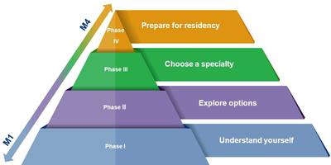
As an initial task, in a Word document that doesn’t exceed one page (~350 – 400 words), please write about the following and return to Student Affairs (StudentAffairsMed@umanitoba.ca) via email no later than Sunday, August 29 at 16:00 hrs.
Email Subject should read: Med 1 Introductory Professional Development Assignment
In one page total (~350 – 400 words) write about the following to the best of your ability; please do not spend more than about 30 minutes on this task:
- Describe your journey to medical school; include your reason or motivation for aspiring to practice medicine.

- Explain how would a family member or a friend describe your best strength(s); write about 1 to 3 strengths.

- Have you identified an area of medicine in which you would like to practice?
  - If so, please identify
  - If not, no big deal. Please state none chosen.

