Your Name: _________________
Welcome Back Med2s
Building on the career sessions that you had with Harpreet Dade and Jim McLaren last year, we are continuing to help you in developing your ability to set effective goals, work towards and plan a successful outcome to your studies. Moving forward, there will be tasks assigned to you that will help you develop necessary skills, cognitions and abilities in relationship to developing into a competent physician.
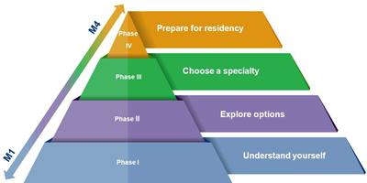
Last year you were exposed to CiM Model. We anticipate that you have added and will continue to build your portfolio based on the model.
These tasks are not part of your Undergraduate Medical Education (UGME) file, will not be graded, and will not be seen by any of the teaching faculty. Harpreet Dade (Career Consultant) and Jim McLaren (Professional Certified Coach) will review the documents and provide feedback to help you in your journey. It is in your best interest to complete them with intent and meaning, so that we can support you leading up to the CaRMS application process and you can continue your own career and professional development into residency and beyond.
As an initial task, in a Word document that doesn’t exceed one page (~350 – 400 words), please write about the following and return to Student Affairs (StudentAffairsMed@umanitoba.ca) via email no later than Sunday, August 29, 2021.
Email Subject Line should read: Med 2 Professional Development Assignment
In one page total (~350 – 400 words) write about the following to the best of your ability; please do not spend more than about 30 minutes on this task:
- Describe how you spent your summer. What went well for you over the summer? What would you say you would pat yourself on the back for (what are you proud of)?

- What are your goals, if any, for the upcoming year? What are some specific areas you want to work on in order to achieve your goal(s)?

- Have you identified an area(s) of medicine in which you are considering to practice?
  - If so, please identify
  - If not, please state none chosen.

- Have you added items to your portfolio to capture your experiences in year 1 of Med school to facilitate step 1 (understand yourself) of the CiM Model? We encourage to start now, if you haven’t already. Then carve out some time to reflect on your experiences. If done with intention, reflection can help you understand yourself better and help you find clues to actively guide your career journey. By reflecting on your studies and activities you engaged in, you can learn a lot about who you are, your likes and dislikes, and what excites you. This will allow you to inform your way forward and move through your studies with more intentionality. Briefly describe what you have learned and any new perspectives you have gained. Has this clarified your assumptions and beliefs?

